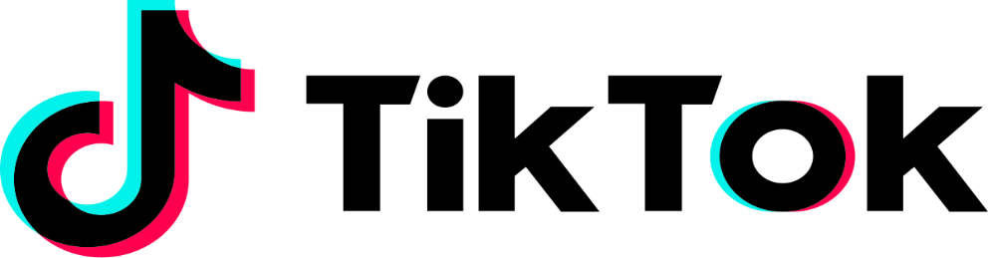

Contact:
Name: Marwan Abdelgawad Phone: ******** Email: *******
TikTok partners with the New York Yankees for the 2023 season For the next 162 games a TikTok patch will appear on the Yankee’s team uniform #TikTok x Yankees2023

Los Angeles, CA., December 15, 2022 – TikTok Announces the new partnership with one of the most famous baseball teams in the world the New York Yankees. A TikTok patch will be appearing on the Yankees’ uniform for every single game of the season which is 162 games, this patch will also be one of the first sponsors for the Yankees this season making TikTok Yankees main sponsor.
After TikTok heard that for the first time Major League Baseball teams will be able to have sponsor patches directly on their uniform (all patches will be 4-by-4 inches either on the left or right sleeve of the uniform) for everyone to see on the field, They immediately took the opportunity to talk to one of the most loved Baseball teams and sponsor them for the rest of the season.
“We’re very excited to announce our new partnership with the New York Yankees, we had to seize the opportunity the second we found out that Major League Baseball teams will be able to have sponsor patches” said Sofia Hernandez, Global Head of Business Marketing of TikTok. “Can’t wait to create and hold events with the Yankees team, this partnership will open many doors for both of us!”
This partnership will be one of the very first TikTok sports partnerships but certainly not last, since news have been arising about how basketball teams will also have patches on their uniform, so TikTok has already been talking to some of the biggest basketball teams negotiating for future partnership.
“We definitely didn’t expect to be sponsored by a brand that has nothing to do with sport, but we’re very excited because this expands the type of sponsors sports teams can have” said Brian Cashman, General Manager of the New York Yankees. “The team will also be having a lot of fun with this sponsor ship since they’ll be creating videos and be involved in campaigns with the new sponsor”
- MORE –
This partnership opened doors for 11 Major League Baseball ambassadors. Everyone that will be using #MLBCreatorClass will have an opportunity to be enter the inaugural program and will get the chance to work with the Yankees team and create videos throughout the season.
TikTok would also like to remind everyone that they’re still sponsoring the Portland Timber of Major League Soccer and Thorns FC of the National Women’s Soccer League, and that they got really exciting news that are coming up for the both teams, so don’t forget to use both teams hashtags will creating videos for a chance to win a full paid trip to watch these teams perform live.
About TikTok:
TikTok is the leading destination for short-form mobile video. Our mission is to inspire creativity and bring joy. TikTok has global offices including Los Angeles, New York, London, Paris, Berlin, Dubai, Mumbai, Singapore, Jakarta, Seoul, and Tokyo.

# # #

